1. Look for **pimCatalog** ARD.

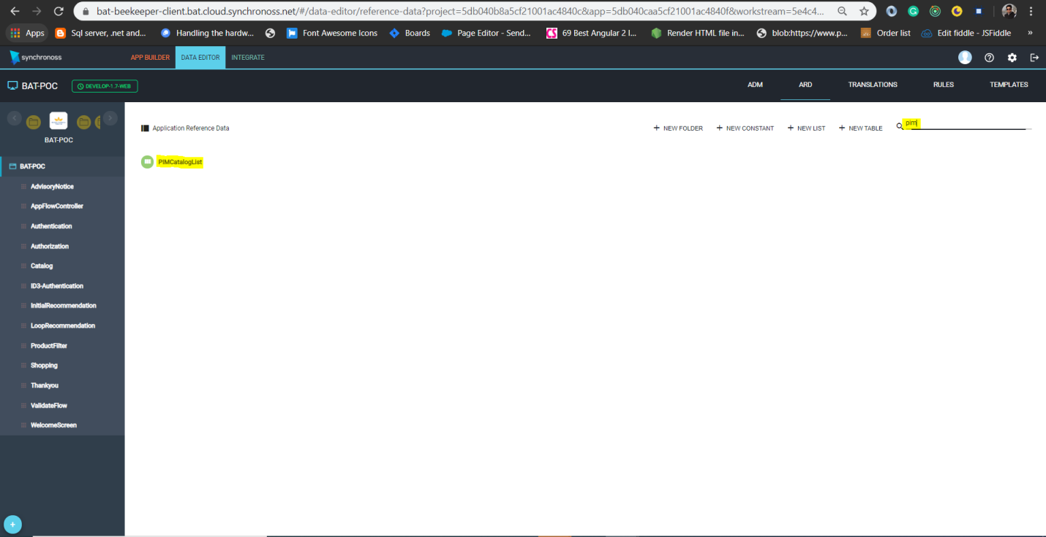

1. Update respective pimid, for now we don’t use category_id.

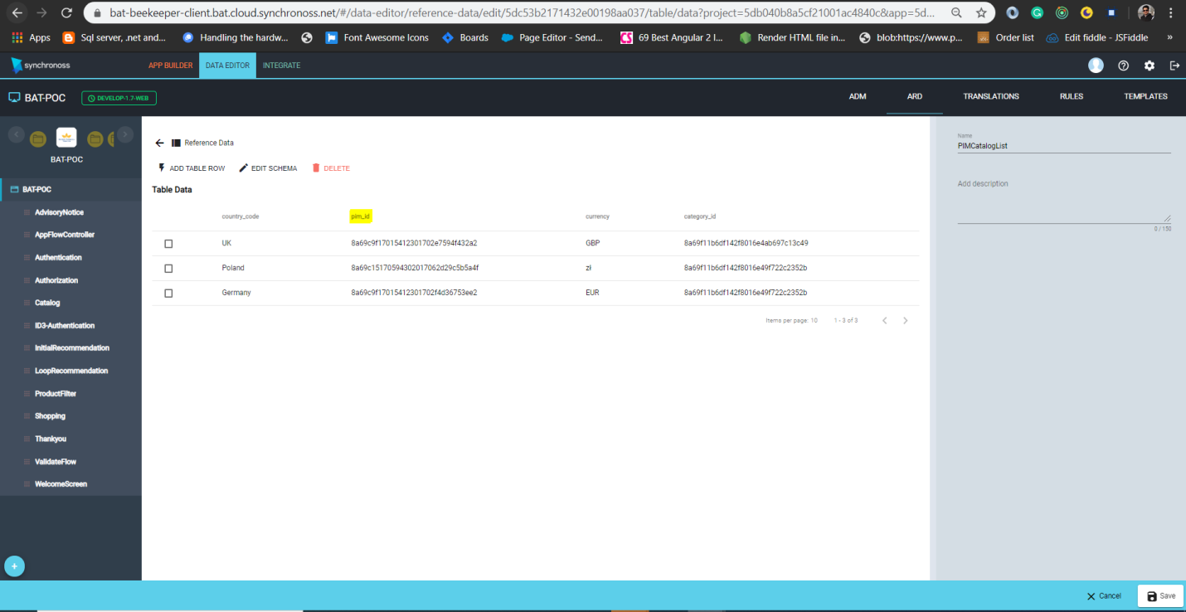

1. Go to **Version -> Deploy**, select **e01** for web(fronten-ui) and **e02** for app.

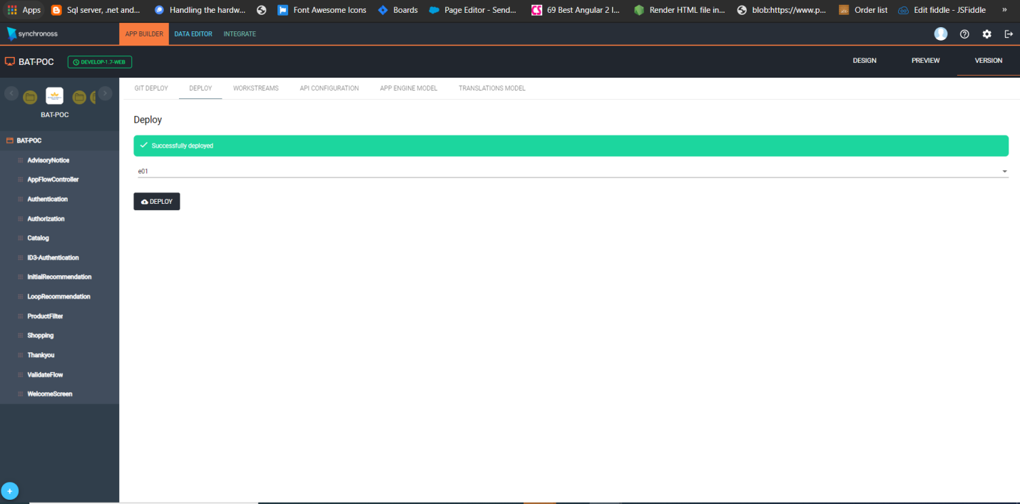

Note: We have created separate workstream for web and app deployment.

**Web(fronten-ui)** : Latest workstream for web is **Develop-1.7-web,** thisshould be deployed on **e01.**

**App** : Latest workstream for app is **Release-1.7,** thisshould be deployed on **e02.**